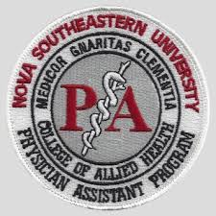

NSU Fort Myers PA New Student Open House
Optional Attendance for all New PA students who have not yet visited Campus
Family are welcome to attend and meet the faculty, tour the campus, and ask questions
Friday, May 10, 2024
Nova Southeastern University – Ft Myers
3650 Colonial Ct.
Fort Myers, FL 33913
Open House – please choose one time from below:

Indicate number of guests including yourself _____ 9 AM – 11 AM

Indicate number of guests including yourself _____ 11 AM – 1 PM

Indicate number of guests including yourself _____ 1 PM – 3 PM

Name: ___________________________________________________________________
RSVP by returning this form by Friday April 12, 2024, to Christy at csaunders@nova.edu

